Concept Block Three: Astronomy

- In this section we will concentrate on the following standard and its components:

Standard: 4Sc: The student will demonstrate an understanding of the properties,
movements, and locations of objects in the solar system. (Earth Science)

- These concepts correspond to the following sections in the Scott Foresman textbook:
- Chapter 4: “Movements in the Solar System” Pages C95-121

- These concepts are encountered in the following Reading Street stories and articles:
- The Stranger (Unit 3)
- Time for A Change (Unit 3)
- How Night Came From The Sea (Unit 3)
- The Ant And The Bear (Unit 3)
- Antarctic Journey (Unit 5)
- Moonwalk (Unit 5)
- A Walk On the Moon (Unit 5)
- The Man Who Went To The Far side Of the Moon (Unit 6)
- The Earth and the Moon (Unit 6)

- In this section we will concentrate on the following standard and its components:

Standard: 4Sc: The student will demonstrate an understanding of the properties,
movements, and locations of objects in the solar system. (Earth Science)

4Sc.1: Recall that Earth is one of many planets in the solar system that orbit the Sun.

4Sc.2: Compare the properties (including the type of surface and atmosphere) and the
location of Earth to the Sun, which is a star, and the Moon.

4Sc.3: Explain how the Sun affects Earth.

4Sc.4: Explain how the tilt of Earth’s axis and the revolution around the Sun results in the seasons of the year.

4Sc.5: Explain how the rotation of Earth results in day and night.

4Sc.6: Illustrate the phases of the Moon and the Moon’s effect on ocean tides.

4Sc.7: Interpret the change in the length of shadows during the day in relation to the
position of the Sun in the sky.

4Sc.8: Recognize the purpose of telescopes.

- Concept Block 3 Content Summary

4Sc.1: Recall that Earth is one of many planets in the solar system that orbit the Sun.

- There are eight or nine planets in our solar system, depending on whether or not you acknowledge Pluto as a planet (that’s an interesting conversation to have with your students). Earth is one of many. We are the ‘3rd rock from the sun”. All of these planets orbit the sun.
- The order of the planets from closest to the sun is: Mercury, Venus, Earth Mars, Jupiter, Saturn, Uranus, Neptune, and Pluto (*). You can easily remember the order of planets by remembering the sentence “My Very Eager Mother Just Served Us Nine Pizzas” or “My Very Eager Mother Just Served Us Noodles” if you exclude Pluto.

4Sc.2: Compare the properties (including the type of surface and atmosphere) and the
location of Earth to the Sun, which is a star, and the Moon.

- The Earth is a terrestrial or “rocky” planet that orbits the sun. The entire surface of the Earth is covered in rock, which may in turn be covered in soil and vegetation, or water. The Earth has a thin gaseous layer know as the atmosphere. The atmosphere is made mostly of Nitrogen gas. The atmosphere acts a blanket, holding in heat. This is what makes the planet habitable.

- The Moon is a rocky satellite that orbits the Earth. It is about ¼ the size of the Earth. The moon’s surface is rocky and barren. It does not have soil or water on its surface. The moons atmosphere is far too thin to hold in heat, so its surface is subjected to extremes of hot and cold. There is no known life on the moon.

- The sun is 100 times bigger than the Earth. It is 93,000 miles away, yet it produces more than enough energy to burn your skin on a sunny day. The sun is made out of a superheated substance called plasma. All of the planets in the solar system revolve around the sun.

4Sc.3: Explain how the Sun affects Earth.

- The sun is massive and has enough gravitational force to hold the Earth and other planets in its orbit.

- The sun is the primary source of energy for almost every organism on Earth. Plants use sunlight to make food, and animals in turn eat plants thus deriving energy indirectly from the sun. In that respect we are “solar powered”.

- The sun’s rays convert into heat when they hit the Earth. That heat warms the planet.

- The uneven heating and cooling of the Earth causes our weather. The sun is the energy source that runs the water cycle.

4Sc.4: Explain how the tilt of Earth’s axis and the revolution around the Sun results in the seasons of the year.

- The Earth rotates on its axis like a basketball rotates on a finger tip. It spins in place. It takes 24 hours for it to make one complete revolution. If the Earth sat straight up and spun like a top, we would have 12 hours of day and 12 hours of night. Instead, the Earth is tilted a bit on its axis, so the length of our days changes from season to season.

- While the Earth is spinning on its own axis, it is also following a path around the sun. The Earth makes a complete orbit around the sun every 365 days. It takes 24 hours for Earth to rotate on its axis; it takes a year for it to complete a revolution around the sun.

- It is the tilt of the Earth and NOT its elliptical orbit that causes the seasons. Although the Earth is at times closer and farther away from the sun, this does not have a great effect on the seasons. The tilt does. During our winter (December-February), the northern hemisphere tilts away from the sun, while the southern hemisphere tilts toward it.

The diagram below demonstrates what happens:
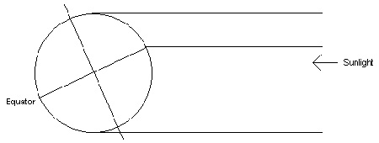
Source: How Stuff Works

In this case, the southern hemisphere is exposed to a lot more sunlight than the northern hemisphere. The tables will be reversed in six months when it is the northern hemisphere basking in sunlight. When it’s winter here it’s summer in Australia!

4Sc.5: Explain how the rotation of Earth results in day and night.

- At any given time half of the Earth is facing the sun, while the other half is immersed in the darkness of space. Hence, while the folks on the sunny side are experiencing day time, the folks on the dark side are having night. Since the Earth is constantly turning we all experience night and day. We all have our time in the sun.

4Sc.6: Illustrate the phases of the Moon and the Moon’s effect on ocean tides.

- The moon, like the earth is stuck between the sun and the blackness of space, half of its surface illuminated half of it in the dark. However, since the moon is in orbit around the earth, its sunny side isn’t always facing us. On some nights we see a full round moon reflecting the suns light. On some nights we see just a bit of that reflective surface. Some nights the sunny side is blocked entirely from our view.

- These different views of the moon are what we call moon phases. Every 29 days we go from a dark (new) moon to a full moon and back again. When the moon is directly in between the sun and the earth we don’t see any light. Over time we see a sliver of light appear on the right. That sliver grows bigger and bigger until it covers half and then the entire visible surface of the moon. See the chart below.

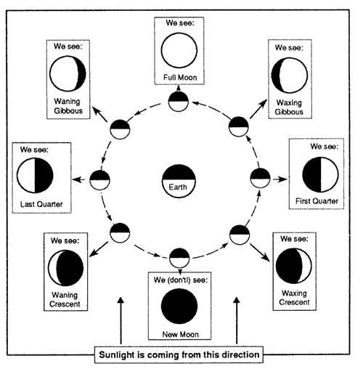Source: astrosociety.org

- The Moon is involved in a tug –o-war with the Earth. The Earth, with its greater gravitational pull, keeps the moon firmly in its orbit, but the moon also pulls at the earth. It pulls hard enough that it can actually pull the water in the ocean toward it a little bit. The water actually mounds up on the side of the Earth closest to the moon, as the moon strains to pull it away. This takes a bit of water away from the oceans in other areas. This is the basis of the tides. The side closest to the moon experiences high tide while the side farthest away has low tide. This situation reverses itself as the earth rotates, so that every seaside area experiences both low and high tide regularly.

4Sc.7: Interpret the change in the length of shadows during the day in relation to the
position of the Sun in the sky.

- Light energy travels in waves from the sun. As those waves hit the surface of objects on Earth they bounce off and ricochet around. Therefore, objects can block light leaving areas of low light behind them. These are shadows. We know that the sun rises in the east and sets in the west. It appears to track across the sky from low in the east to low in the west. It appears right over head around noon. So, the sun creates shadows and is constantly moving. Therefore, the shadows that the sun casts will be different at different times of the day. They will change in length and position. The ancient Romans figured this out thousands of years ago and used their knowledge to build the first clocks, sundials.

4Sc.8: Recognize the purpose of telescopes.

- If I want to look at things that are to tiny for me to see, I will use a microscope. It will make things look much bigger and will show me details I couldn’t otherwise see. If I want to see a planet or star that is too far away for me to see, I will use a telescope. It’s like a microscope for the sky. A telescope is essentially a tube with a magnifying lens at each end. It works much like a microscope, making things appear larger, and showing details that could not be otherwise seen. Of course, we have to remember that planets and stars only appear tiny due to the fact they are billions of miles away.

- Suggested Resources:
The following sites provide activities and ideas in support of the above standards. Some can be used as is; others may need to be leveled for use in the fourth Grade classroom. All of them can be used as references to provide ideas for assisting your instruction.

4Sc.1: Recall that Earth is one of many planets in the solar system that orbit the Sun.
http://www.kidsastronomy.com/solar_system.htm

http://www.planetsforkids.org/

http://www.kids.nineplanets.org/

http://www.neok12.com/video/Solar-System/zX0148504f7b680c42727055.htm

4Sc.2: Compare the properties (including the type of surface and atmosphere) and the
location of Earth to the Sun, which is a star, and the Moon.

http://www.sciencekids.co.nz/gamesactivities/earthsunmoon.html

http://www.planetsforkids.org/moon-moon.html

http://resources.woodlands-junior.kent.sch.uk/time/moon/facts.htm

http://www.kidsgeo.com/geography-for-kids/0018-the-rotation-of-the-earth.php

4Sc.3: Explain how the Sun affects Earth.

http://www.windows2universe.org/sun/effect_on_earth.html

http://www.esa.int/Our_Activities/Space_Science/How_the_Sun_affects_us_on_Earth

4Sc.4: Explain how the tilt of Earth’s axis and the revolution around the Sun results in the seasons of the year.

http://library.thinkquest.org/29033/begin/earthsunmoon.htm

http://scienceforkids.kidipede.com/physics/weather/seasons.htm

http://www.kidsgeo.com/geography-for-kids/0017B-reasons-for-the-four-seasons.php

4Sc.5: Explain how the rotation of Earth results in day and night.

http://science.howstuffworks.com/environmental/earth/geophysics/earth2.htm

http://www.lpi.usra.edu/education/skytellers/day_night/

http://teachers.net/lessons/posts/837.html

4Sc.6: Illustrate the phases of the Moon and the Moon’s effect on ocean tides.

http://www.sciencebob.com/blog/?p=828/

http://analyzer.depaul.edu/paperplate/Oreo%20Moon%20Phases.htm

http://www.sciencekids.co.nz/pictures/space/moonphases.html

4Sc.7: Interpret the change in the length of shadows during the day in relation to the
position of the Sun in the sky.

http://scienceprojectideasforkids.com/2009/sun-shadows/

http://donnayoung.org/science/shadow-chart.htm

4Sc.8: Recognize the purpose of telescopes.

http://www.kidsastronomy.com/telescopes.htm
http://www.thefreeresource.com/facts-about-telescopes-for-kids

