Concept Block Four: Weather

- In this section we will concentrate on the following standard and its components:

Standard: 4Sd: The student will demonstrate an understanding of weather patterns and phenomena. (Earth Science)

4Sd.1: Summarize the processes of the water cycle (including evaporation, condensation, precipitation, and runoff).

4Sd.2: Classify clouds according to their three basic types (cumulus, cirrus, and stratus) and summarize how clouds form.

4Sd.3: Compare daily and seasonal changes in weather conditions (including wind speed and direction, precipitation, and temperature) and patterns.

4Sd.4: Summarize the conditions and effects of severe weather phenomena (including thunderstorms, hurricanes, and tornadoes) and related safety concerns.

4Sd.5: Carry out the procedures for data collecting and measuring weather conditions
(including wind speed and direction, precipitation, and temperature) by using
appropriate tools and instruments.

4Sd.6: Predict weather from data collected through observation and measurements.

- These concepts correspond to the following sections in the Scott Foresman textbook:

- Chapter 1 Pages C5-C31
- These concepts are encountered in the following Reading Street stories and articles:

- Eye of the Storm (Unit 3)
- Severe Weather Safety (Unit 3)

- Concept Block 4 Content Summary

4Sd.1: Summarize the processes of the water cycle (including evaporation, condensation, precipitation, and runoff).

- The key to understanding the water cycle is a basic understanding of water molecules and energy. Individual water molecules are tiny, so tiny that there are billions of them in a single rain drop. As you add energy to water molecules they begin to buzz around and bump in to each other. If enough energy is added they will begin to ricochet out into the air as a gas. If you remove energy from them they will calm down and stay together in a liquid. If you cool them down enough, they will pack in together forming a solid, ice. So if we put an ice cube in a pan on a hot stove it will change. The heat will add energy to the tiny molecules. They will begin to buzz more and more. Initially they will slip and slide over each other as a liquid. Eventually they will get so fired up they will jump right out of the pan as water vapor.

- The surface of the earth is like a giant pan that is heated by the sun. It causes water to freeze, melt, or turn to vapor depending on the amount of available energy. There really isn’t enough sunlight at the poles to excite water molecules much, so they tend to hang out there as solid ice and snow. At the equator, the suns energy is intense, so there is no snow or ice, but lots of liquid water and water vapor. That’s why the rainforests are all located around the equator.

- Water molecules go through this freeze-melt-vaporize thing regularly. Driven by the suns energy, they heat up and cool down, going from solid to liquid to gas and back again. This is referred to as the water cycle.
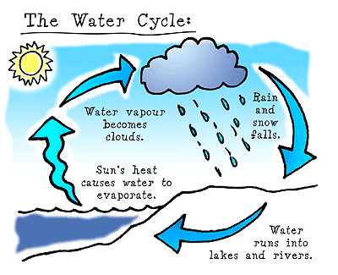Source: La Session Europa

- Freezing- When water goes from a liquid to a solid (Loses energy)
Melting- When water goes from solid to liquid (gains energy)
Evaporation- When water goes from liquid to gas (gains energy)
Condensation- When water goes from gas to liquid (loses energy)
Precipitation- When water falls as rain or snow
Run off- When water runs from land into streams, lakes, and oceans

So, a little fancier…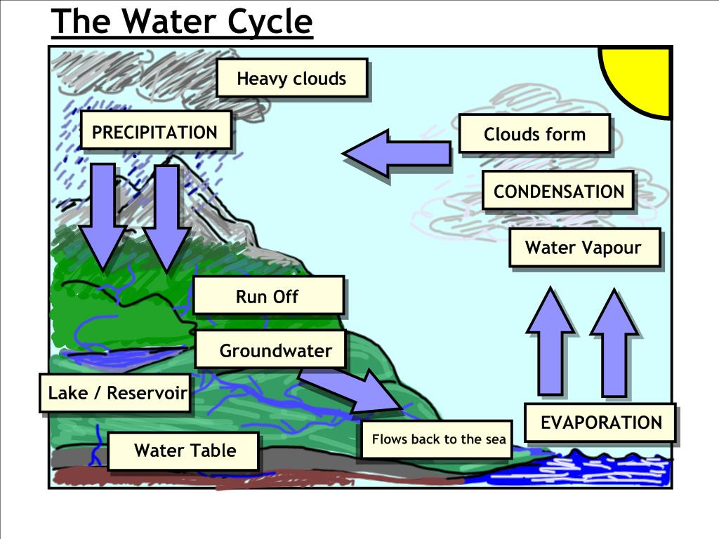
Source: T. Barret

4Sd.2: Classify clouds according to their three basic types (cumulus, cirrus, and stratus) and summarize how clouds form.

- Clouds form when the air in the upper atmosphere is cooler that the air that is near the ground. It is all part of the water cycle. Water vapor rises when heated (vaporization). Then it rises into the air encountering cooler temperatures. This causes the water molecules to lose energy and pull together (condensation). If enough water collects, it will become heavy and fall to the earth (precipitation).

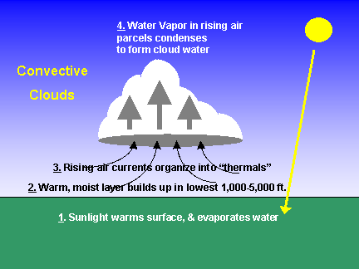
Source: weatherquestions.com
- Clouds can be placed into three basic groups based on their appearance, and when and how they form:

- Cumulus Clouds- these are the big puffy, cotton candy clouds we see on nice days. They are usually associated with nice warm days

- Cirrus Clouds- these clouds form high up in the atmosphere. They are made of mostly ice crystals. They look like thin layers stacked up in bands.

- Stratus Clouds- Are low, flat clouds. They often look like a white blanket spread out across the sky. These are typical rainy day clouds.

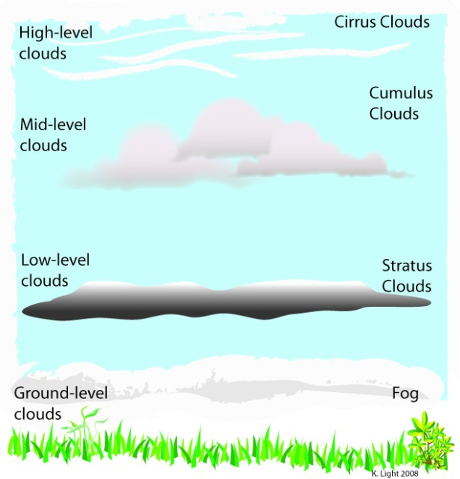

4Sd.3: Compare daily and seasonal changes in weather conditions (including wind speed and direction, precipitation, and temperature) and patterns.

4Sd.4: Summarize the conditions and effects of severe weather phenomena (including thunderstorms, hurricanes, and tornadoes) and related safety concerns.

4Sd.5: Carry out the procedures for data collecting and measuring weather conditions
(including wind speed and direction, precipitation, and temperature) by using
appropriate tools and instruments.

4Sd.6: Predict weather from data collected through observation and measurements.

- Suggested Resources:
The following sites provide activities and ideas in support of the above standards. Some can be used as is; others may need to be leveled for use in the fourth Grade classroom. All of them can be used as references to provide ideas for assisting your instruction.

4Sd.1: Summarize the processes of the water cycle (including evaporation, condensation, precipitation, and runoff).

http://www.buzzle.com/articles/water-cycle-for-kids.html

http://www.sciencekids.co.nz/sciencefacts/weather/thewatercycle.html

http://www.watereducation.org/doc.asp?id=1022

http://ga.water.usgs.gov/edu/watercycle-kids.html

4Sd.2: Classify clouds according to their three basic types (cumulus, cirrus, and stratus) and summarize how clouds form.

http://www.weatherwizkids.com/weather-clouds.htm

http://www.kidskonnect.com/subjectindex/15-educational/science/67-clouds.html

http://mynasadata.larc.nasa.gov/804-2/clouds-for-kids/

4Sd.3: Compare daily and seasonal changes in weather conditions (including wind speed and direction, precipitation, and temperature) and patterns.

http://weatherwizkids.com/weather-experiments.htm

http://weatherwizkids.com/

http://www.weatherwizkids.com/weather-forecasting.htm

4Sd.4: Summarize the conditions and effects of severe weather phenomena (including thunderstorms, hurricanes, and tornadoes) and related safety concerns.

http://www.crh.noaa.gov/gid/?n=weatherforkids

http://www.lightningsafety.noaa.gov/kids.htm

http://www.nws.noaa.gov/os/educ/experiments.htm

4Sd.5: Carry out the procedures for data collecting and measuring weather conditions
(including wind speed and direction, precipitation, and temperature) by using
appropriate tools and instruments.

http://blog.ctnews.com/mcneill/2011/08/25/weather-science-experiments-for-kids-make-your-own-weather-instruments/

http://www.weatherwizkids.com/experiments-anemometer.htm

http://www.weatherwizkids.com/experiments-barometer.htm

http://www.kidskreate.com/rain_guage.htm

4Sd.6: Predict weather from data collected through observation and measurements.

http://www.eo.ucar.edu/webweather/
http://www.air-n-water.com/weather-forcasting-for-kids.htm

