Concept Block Two: How Ecosystems Function

- In this section we will concentrate on the following standard and its components:

Standard: 5Sb: The student will demonstrate an understanding of relationships among biotic and abiotic factors within terrestrial and aquatic ecosystems.

5Sb.1: Recall the cell as the smallest unit of life and identify its major structures
(including cell membrane, cytoplasm, nucleus, and vacuole).

5Sb.2: Summarize the composition of an ecosystem, considering both biotic factors
(including populations to the level of microorganisms and communities) and
abiotic factors.

5Sb.3: Compare the characteristics of different ecosystems (including estuaries/salt
marshes, oceans, lakes and ponds, forests, and grasslands).

5Sb.4: Identify the roles of organisms as they interact and depend on one another
through food chains and food webs in an ecosystem, considering producers
& consumers (herbivores, carnivores, and omnivores), decomposers
(microorganisms, termites, worms, fungi), predator & prey, parasite & hosts.

5Sb.5: Explain how limiting factors (including food, water, space, and shelter) affect
populations in ecosystems.

- These concepts correspond to the following sections in the Scott Foresman textbook:

- A6-A7, Exploring Life Characteristics & Comparing/Contrasting (Activity)

- A8-A13, Life Functions & Cell Characteristics

- A16-A21, Classification by Kingdoms (Extension/Review)

- A22-A23, Observing the Growth of Fungi (Activity)

- A24-A33, Classifying Plants & Animals (Extension/Review)

- A90-A95, Adaptations to Different Climates (Extension/Review)

- A96-A97, Investigating Insulation (Activity/Extension)

- A110-a128, Ecosystem Function

- These concepts are encountered in the following Reading Streets

Stories and articles:

    - Island of the Blue Dolphins (Unit 1)
    - Seven Survival Questions (Unit 1)
    - Jane Goodall’s 10 Ways to Save Wildlife (Unit 2)
    - Why some Animals Are Considered Bad (Unit 2)
    - Exploding Ants (Unit 4)
    - Adapting Lagoon (Unit 4)
    - At the Beach (Unit 6)
    - The Eagle and the Bat (Unit6)
    - The Mystery of St. Matthews Island ( Unit 6)

Concept Block Two: Content Summary

Standard: 5Sb: The student will demonstrate an understanding of relationships among biotic and abiotic factors within terrestrial and aquatic ecosystems.

5Sb.1: Recall the cell as the smallest unit of life and identify its major structures
(Including cell membrane, cytoplasm, nucleus, and vacuole).

- All living things are composed of cells, tiny structures that carry on life
functions. Most organisms are made of billions of these structures working together. They are called multi-cellular organisms. The simplest organisms, like bacteria, have only one cell. They are uni-cellular organisms. Individual cells are too small to be seen with the naked eye. Most cells can be easily observed with a microscope.

- Cells contain smaller units called organelles. Each organelle has a specific job or function within the cell. Basic organelles include; the cell membrane, which regulates substances that enter and leave the cell, the cytoplasm, which is a jelly-like liquid, the nucleus, which controls all cell activity, and vacuoles, which cells use to store waste and cellular products.
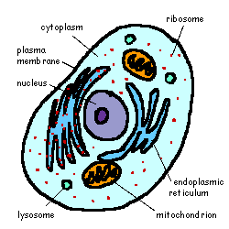
Animal Cell Source: queenoflub.com

- Plant and animal cells share many characteristics, yet are unique. Both plant and animal cells are surrounded by cell membranes, but plant cells also have a rigid cell wall around them. Plants also contain a unique group of organelles called chloroplasts. Chloroplasts give plants their green color, and contain chemicals which allow plants to go through photosynthesis.

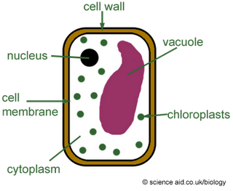

Plant Cell

5Sb.2: Summarize the composition of an ecosystem, considering both biotic factors
(including populations to the level of microorganisms and communities) and
abiotic factors.

Content Summary:

- An ecosystem is an area of interacting living and non-living things. An ecosystem can be quite large, covering many square miles, or very small. The inside of your mouth is an ecosystem that supports many micro-organisms.

- All of the living things in an ecosystem are referred to as biotic factors. These include all of the plants, animals, fungi, and microbes in an area. The word biotic comes from the greek bios, which means living (think biology, or biome). The non-living parts of an ecosystem are called abiotic factors. The prefix “a” in ‘abiotic” stands for anti or not, so combined, “a” and “biotic” mean not alive. These factors include air, water, soil, and weather. There is a constant interaction between biotic and abiotic factors in an area. All are equally important in maintaining a properly functioning ecosystem.

- Ecosystems support limited populations of various species. All of the populations of organisms within an ecosystem form a community. Every organism in a community has a specific habitat or area where it can be found. Each organism has a special niche or job that it does in the ecosystem.

5Sb.3: Compare the characteristics of different ecosystems (including estuaries/salt
marshes, oceans, lakes and ponds, forests, and grasslands).

Content Summary:

- Different areas of the Earth exist under different conditions. Differences in climate and location for example can determine whether an area is a desert or a jungle. Every one of these unique areas supports an array of organisms that are specially adapted to survive there. So, the Earth has quite a variety of both aquatic and terrestrial (land based) ecosystems. These include:

- Wetlands - areas of transition between land and water, including swamps, fresh and salt water marshes, and estuaries.

- Fresh water Bodies- land areas covered in fresh water, including streams, rivers, ponds, and lakes

- Salt Water Bodies- Land areas covered in salt water, including seas and oceans

- Forests- Areas where trees are the main plant form, including tropical rain forests, Coniferous (evergreen) forests, and deciduous (broad-leaf) forests.

- Grasslands- areas covered mostly by grasses, like prairies and the savanna of Africa.

- Deserts- areas where the lack of water limits the growth of plants greatly.

5Sb.4: Identify the roles of organisms as they interact and depend on one another
through food chains and food webs in an ecosystem, considering producers
& consumers (herbivores, carnivores, and omnivores), decomposers
(microorganisms, termites, worms, fungi), predator & prey, parasite & hosts.

Content Summary:

- In order for an ecosystem to function properly it must have a balance of organisms fulfilling different roles. The relationship between these organisms keeps the environment healthy. Despite the variety of ecosystems on Earth, these roles remain consistent. They include:

  - Producers- Organisms like plants and some bacteria that make their own food by going through photosynthesis

  - Herbivores- Animals, like deer, cows, and rabbits, that eat plants. Herbivores are called primary consumers because they get their food directly from the source, plants.

  - Carnivores- Animals like sharks, lions, and snakes, which eat other animals. Carnivores are called secondary consumers because they get their energy from animals that eat plants.

  - Omnivores- Animals like bears, pigs, and humans, that eat both plants and animals

  - Decomposers- Organisms like termites, worms, and fungi, that eat or break down dead matter

- The relationship between these organisms include:

- Predator/Prey- a relationship like snake to mouse, or spider to fly, where one animal catches and eats the other animal.

- Host/Parasite- a relationship like mosquito to man, or tick to dog, where one creature feeds off of another creature without killing it.

- Energy travels through an ecosystem as one organism eats another.
This can be represented as a food chain, or possible feeding
relationship. For example:

Grass →Rabbit→ Fox

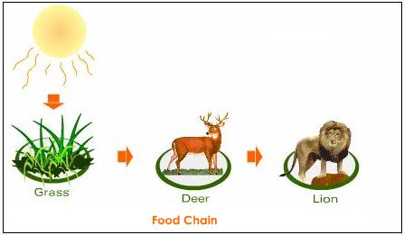

Source: tutor vista.com

This is simple, but not very accurate, as it only shows one possible energy/food path. Many organisms other than deer eat grass. Lions eat creatures other than deer, etc. To be more accurate we must look at all the possibilities. All of the possible feeding relationships in an area combined are referred to as a food web.

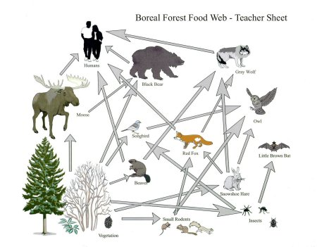

5Sb.5: Explain how limiting factors (including food, water, space, and shelter) affect
populations in ecosystems.

Content Summary:

- All organisms have basic requirements that they need to survive. These include things like food, water, space, and shelter. When the ecosystem can provide these things in abundance the population of a species will thrive and increase. However, this can cause a problem. As a population rises, these resources get spread out amongst more individuals. Eventually there is an imbalance between the number of individuals and the amount of available resources. The need becomes greater than the supply. Therefore many individuals die and the population drops. This is how nature limits populations. The availability of resources determines the number of individuals that an area can support (its carrying capacity). So, things like water, food, space, and shelter, are limiting factors, or things that limit the growth of a population. Other limiting factors include predators and diseases. These factors act as population checks, maintaining balance within an ecosystem. This makes life in the wild difficult for individuals, but is essential for the overall success of the species.

- One way to understand this interaction is to look at the concept of trophics. The word trophic comes from the ancient word trophikos, meaning “to eat”. So trophic means relating to eating or nutrition.
In population science we generally use this as a suffix, and use it to assign roles to organisms.

- Autotrophs- (self-feeding) are plants, or producers. They are “self-feeders”, because they can create their own food during photosynthesis. This allows autotrophs to exist in huge numbers.

- Heterotrophs- (other-feeding) are consumers. They are any organisms that cannot undergo photosynthesis. Animals and fungi are heterotrophs. Both primary and secondary consumers fall into this category.

- Now here’s the key: In order for plant species to survive, there must be enough of them that some plants can be eaten by herbivores, while leaving the rest to reproduce. That means that there can’t be too many herbivores. The job of controlling herbivore populations falls to the predators. Limited numbers of herbivores in turn, keeps predator populations from getting too big. So in any given ecosystem, we expect to see more plants than animals, and more herbivores than carnivores. This is nicely illustrated by the trophic pyramid.

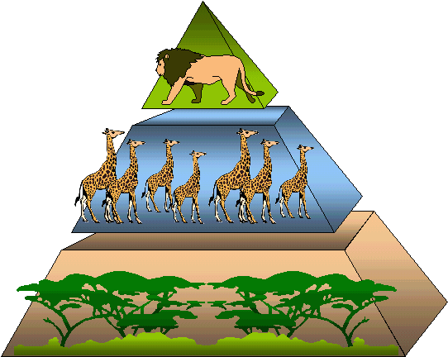

Trophic Pyramid
Source: pangea.tec.selu.edu

In this illustration the wide base represents plants. The plant base supports a smaller level of herbivores (primary consumers), which in turn supports a smaller level of carnivores (secondary consumers). As energy flows up through the food chain less and less of it is available.

- Suggested Resources:
The following sites provide activities and ideas in support of the above standards. Some can be used as is; others may need to be leveled for use in the fifth Grade classroom. All of them can be used as references to provide ideas for assisting your instruction.

5Sb.1: Recall the cell as the smallest unit of life and identify its major structures
(including cell membrane, cytoplasm, nucleus, and vacuole).

http://www.biology4kids.com/files/cell_main.html

http://www.neok12.com/Cell-Structures.htm

http://www.ducksters.com/science/the_cell.php

5Sb.2: Summarize the composition of an ecosystem, considering both biotic factors
(including populations to the level of microorganisms and communities) and
abiotic factors.

http://www.kidsgeo.com/geography-for-kids/0164-ecosystems.php

http://www.neok12.com/Ecosystems.htm

http://www.scribd.com/doc/65409457/Biotic-Abiotic-Activity

5Sb.3: Compare the characteristics of different ecosystems (including estuaries/salt
marshes, oceans, lakes and ponds, forests, and grasslands).

http://www.ducksters.com/science/ecosystems/world_biomes.php

http://environment.nationalgeographic.com/environment/freshwater/aquatic-ecosystems/
5Sb.4: Identify the roles of organisms as they interact and depend on one another
through food chains and food webs in an ecosystem, considering producers
& consumers (herbivores, carnivores, and omnivores), decomposers
(microorganisms, termites, worms, fungi), predator & prey, parasite & hosts.

http://www.ducksters.com/science/ecosystems/food_chain_and_web.php

http://www.kidskonnect.com/subjectindex/15-educational/science/77-food-chain.html

http://www.ecokids.ca/pub/eco_info/topics/frogs/chain_reaction/index.cfm

5Sb.5: Explain how limiting factors (including food, water, space, and shelter) affect
populations in ecosystems.

http://www.wolfquest.org/classroom_activities.php

http://www.ehow.com/list_6158905_activities-population-growth-limiting-factors.html

